Nama : Angeline Natasya Liong

NIM : 51022002

Laporan Praktikum Modul 8

Cloud Computing

LATIHAN 1

Use BigQuery to import data

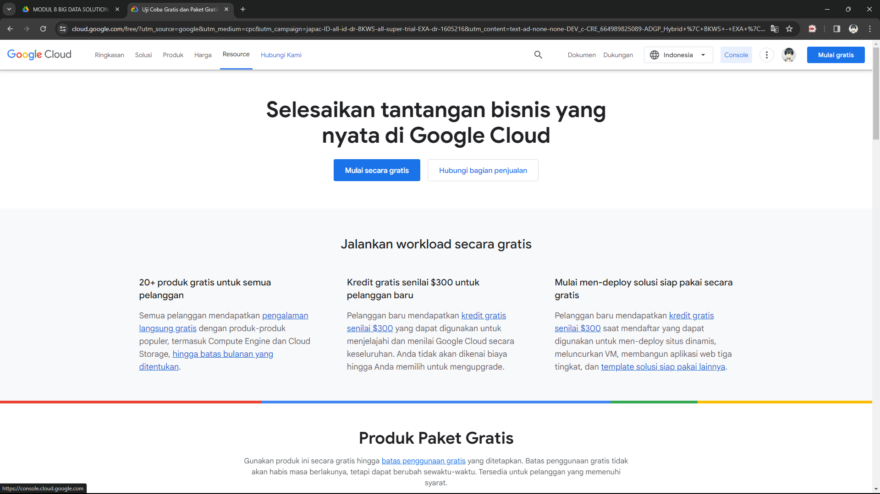

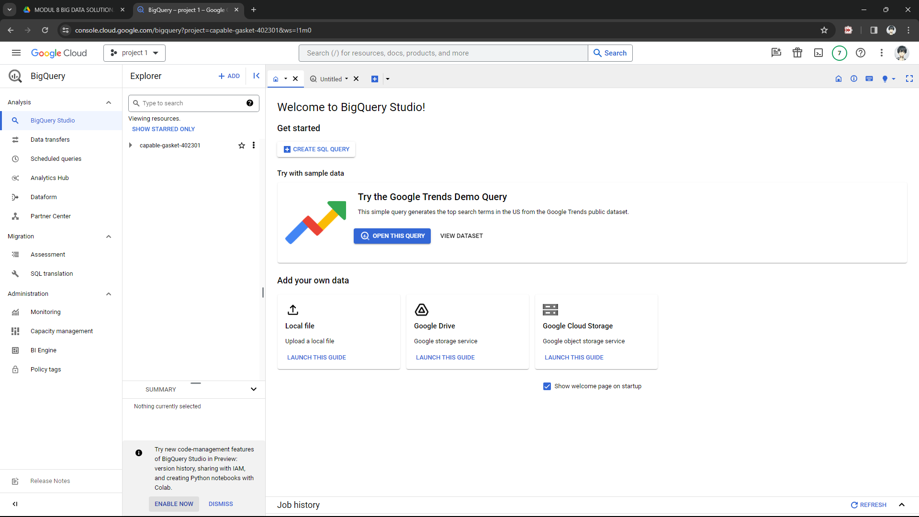

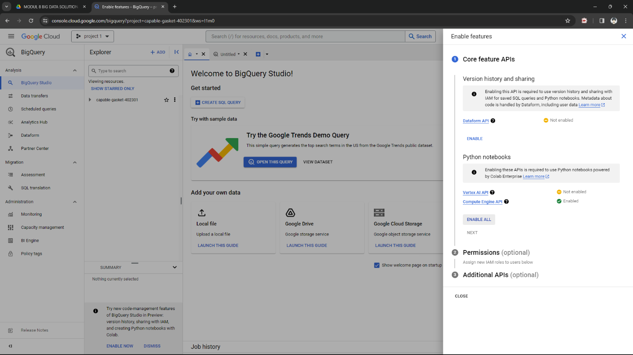

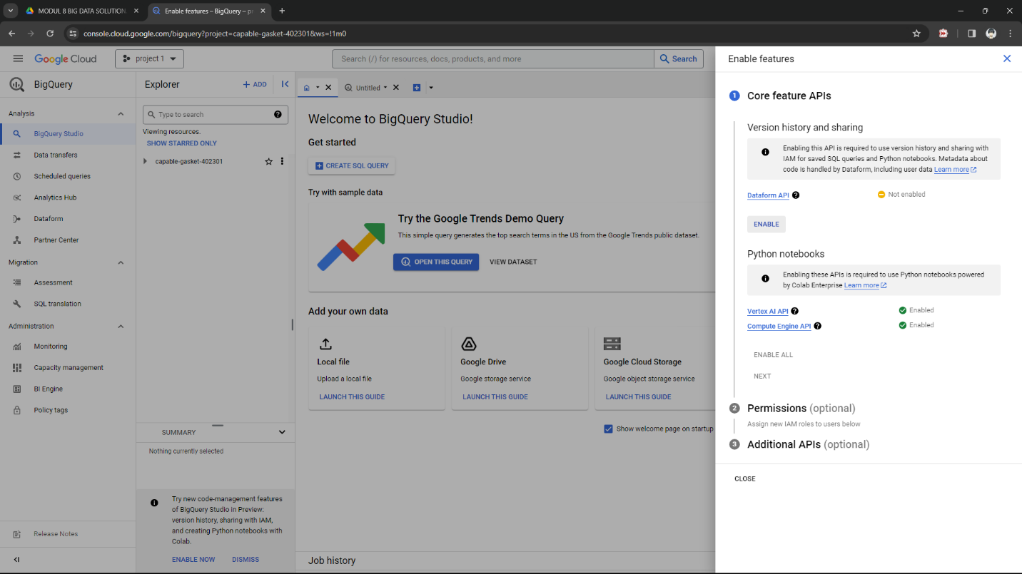

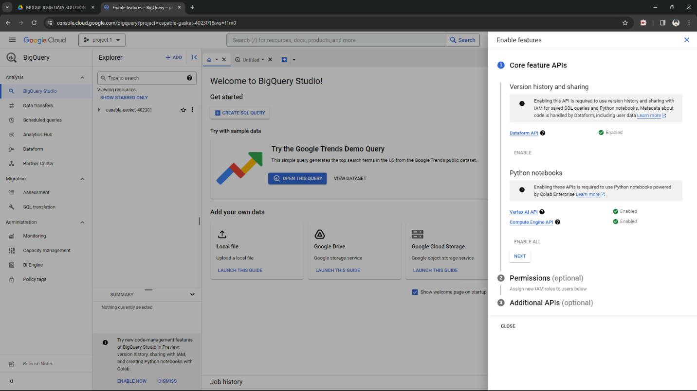

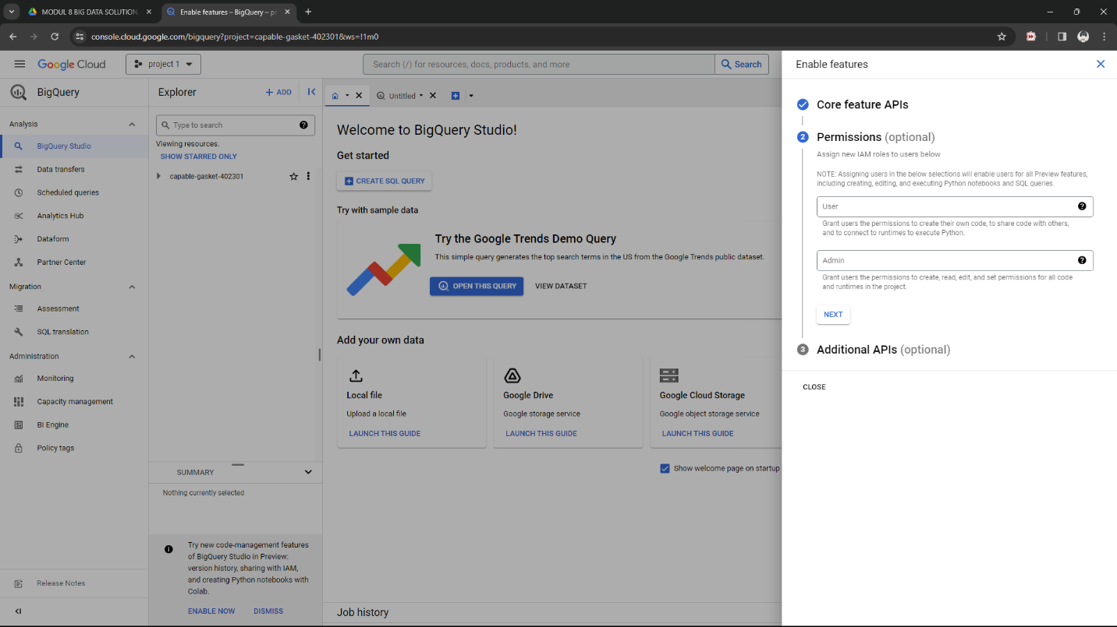

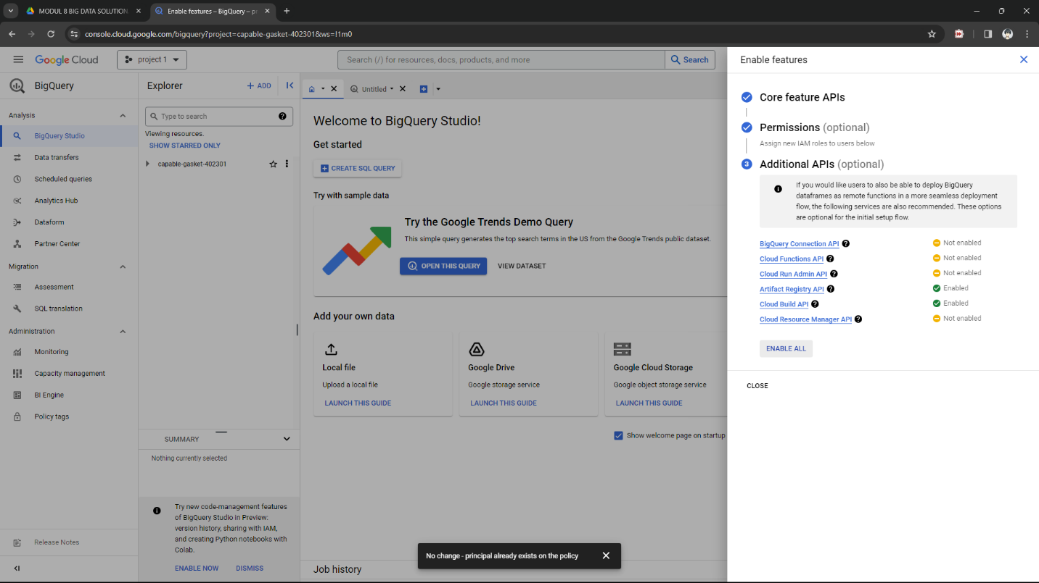

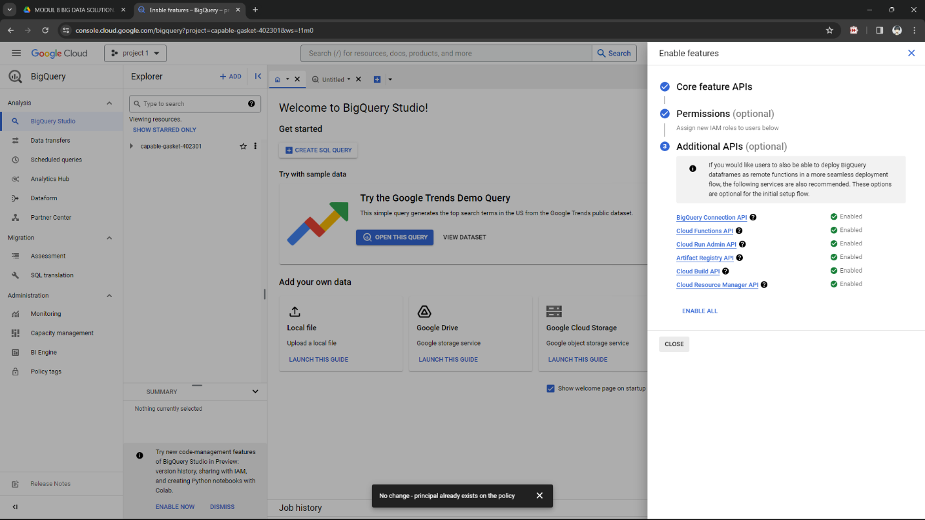

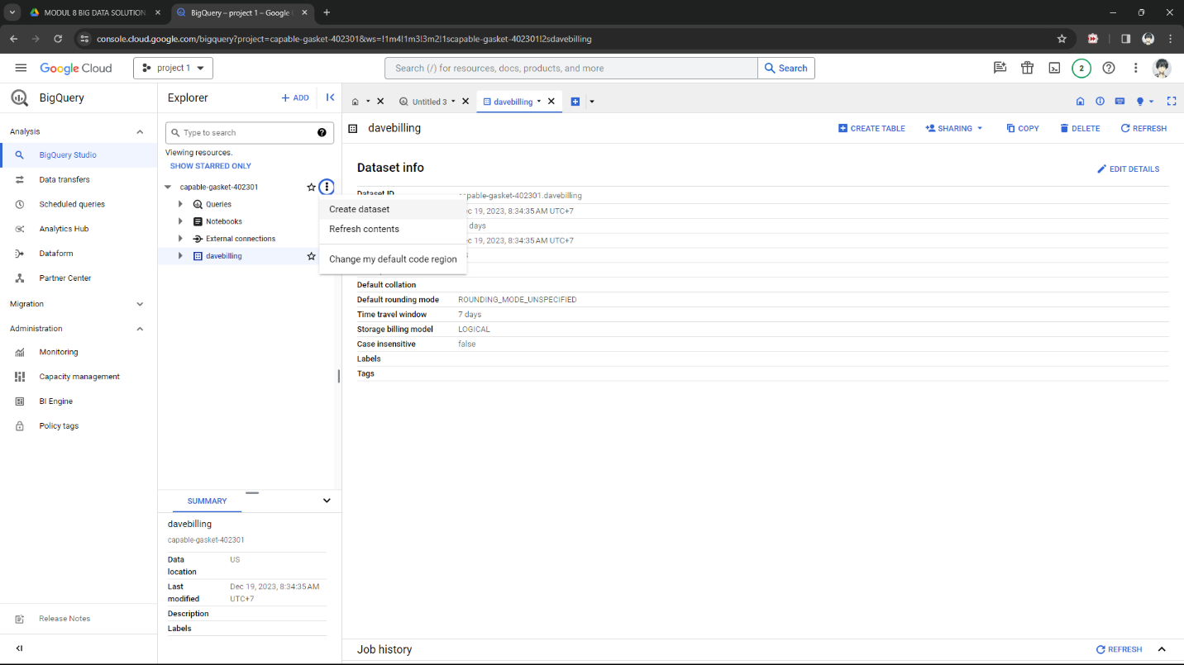

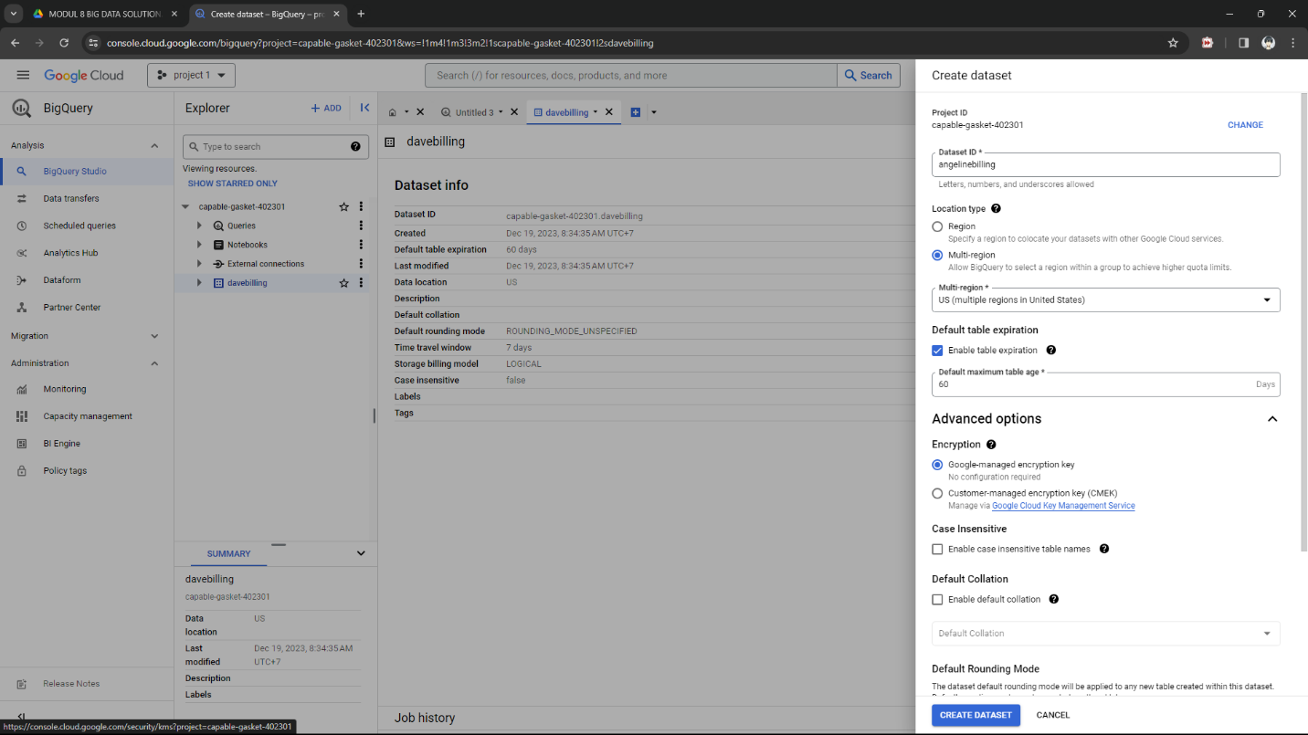

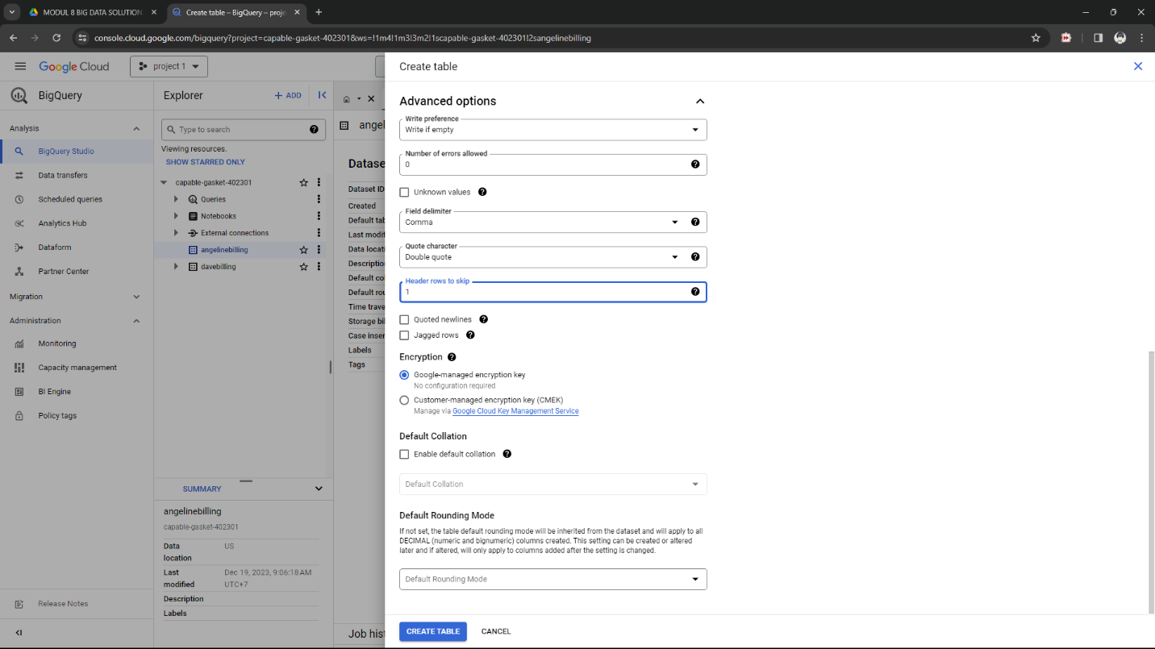

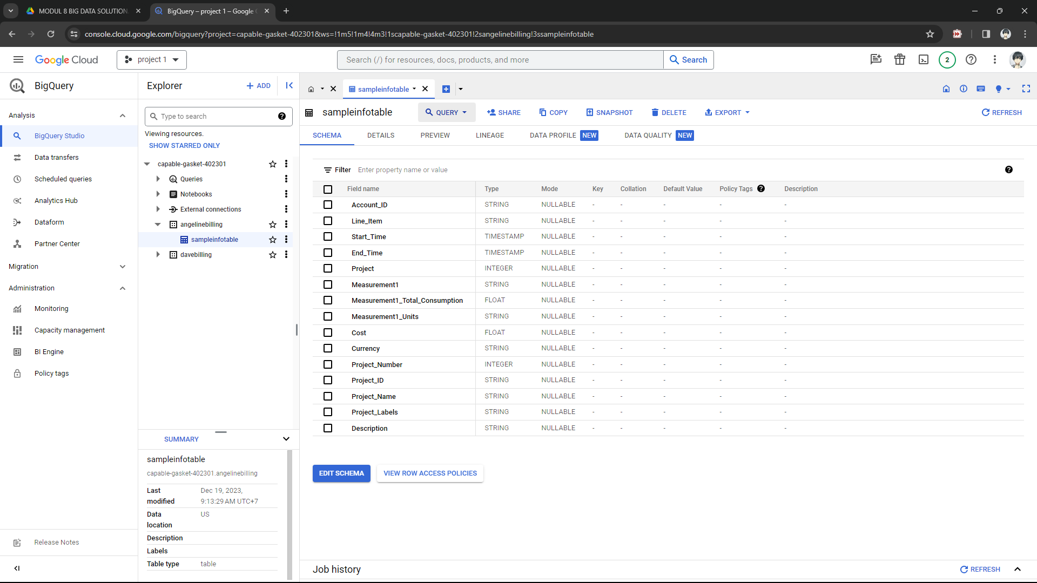

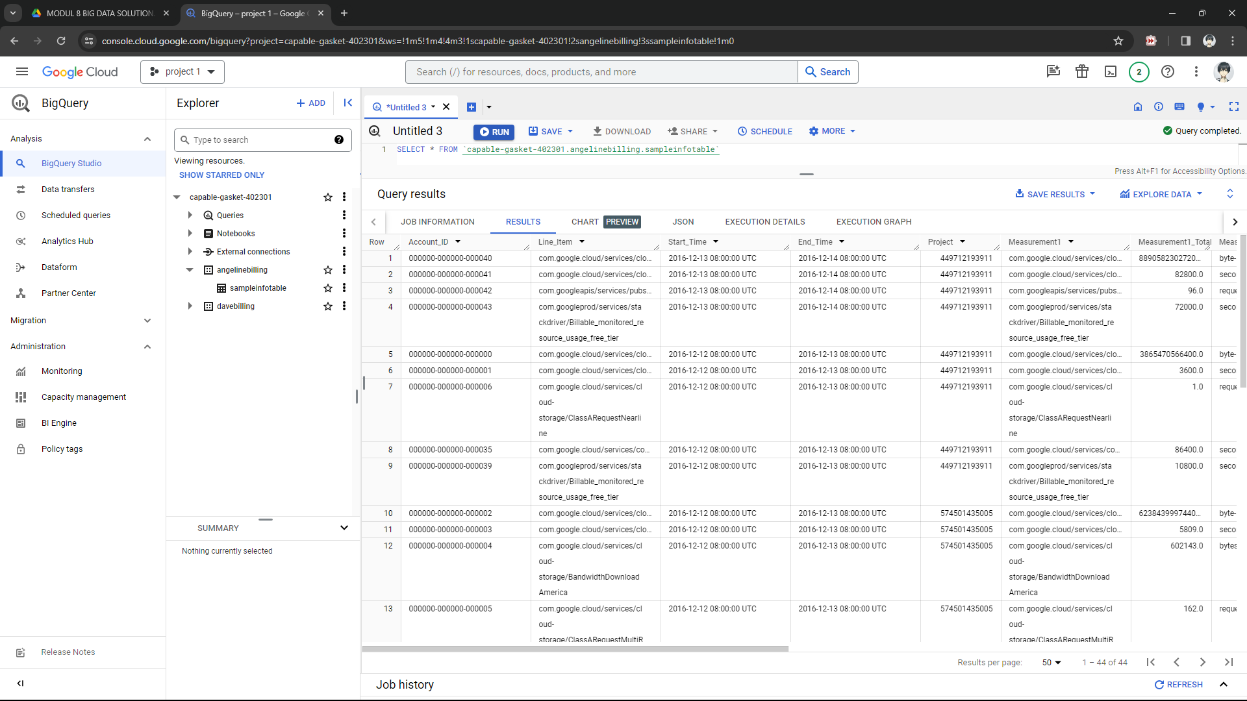

LATIHAN 2

Examine the table

LATIHAN 3

Visualizing BigQuery Data

